- Copyright for test papers and marking guides remains with West Australian Test Papers.
- The papers may only be reproduced within the purchasing school according to the advertised conditions of sale.
- Test papers must be withdrawn after use and stored securely in the school until 30th November.

CHEMISTRY
UNIT 1 & 2
2023

MARKING GUIDE

TIME ALLOWED FOR THIS PAPER

Reading time before commencing work: Ten minutes
Working time for the paper: Two hours and thirty minutes

MATERIALS REQUIRED/RECOMMENDED FOR THIS PAPER

To be provided by the supervisor:
This Question/Answer Booklet
Multiple-choice Answer Sheet
Chemistry Data Book

To be provided by the candidate:
Standard items: pens, pencils, eraser or correction fluid, ruler, highlighter.

Special items: calculators satisfying the conditions set by the SCSA for this subject.

IMPORTANT NOTE TO CANDIDATES
No other items may be taken into the examination room. It is your responsibility to ensure that you do not have any unauthorised notes or other items of a non-personal nature in the examination room. If you have any unauthorised material with you, hand it to the supervisor before reading any further.

Structure of this paper

Section | Number of questions available | Number of questions to be answered | Suggested working time  (minutes) | Marks available | Percentage of exam
Section One  Multiple-choice | 20 | 20 | 40 | 20 | 25
Section Two  Short answer | 8 | 8 | 50 | 62 | 35
Section Three  Extended answer | 4 | 4 | 60 | 72 | 40
 |  |  |  | Total | 100

Section One: Multiple-choice 25% (20 marks)

1 | a ■ b □ c □ d □ |  | 6 | a □ b □ c ■ d □
2 | a □ b □ c □ d ■ |  | 7 | a □ b ■ c □ d □
3 | a □ b □ c ■ d □ |  | 8 | a □ b □ c □ d ■
4 | a ■ b □ c □ d □ |  | 9 | a ■ b □ c □ d □
5 | a □ b □ c ■ d □ |  | 10 | a □ b ■ c □ d □

11 | a □ b ■ c □ d □ |  | 16 | a □ b □ c ■ d □
12 | a □ b □ c □ d ■ |  | 17 | a ■ b □ c □ d □
13 | a □ b □ c □ d ■ |  | 18 | a □ b ■ c □ d □
14 | a □ b ■ c □ d □ |  | 19 | a □ b □ c ■ d □
15 | a □ b ■ c □ d □ |  | 20 | a □ b □ c ■ d □

Section Two: Short answer 35% (62 marks)

Question 21 (8 marks)

(a) Identify a similarity between the gallium-69 and gallium-71 isotopes in terms of;

- their atomic structure. (1 mark)

Description | Marks
Any of the following;  - Same number of protons  - Same number of electrons | 1
Total | 1

- their chemical properties. (1 mark)

Description | Marks
Any of the following;  - Same reactivity  - Same ion charge  - Same bonding capacity | 1
Total | 1

(b) Identify a difference between the gallium-69 and gallium-71 isotopes in terms of;

- their atomic structure. (1 mark)

Description | Marks
Any of the following;  - Different number of neutrons  - Different mass number | 1
Total | 1

- their physical properties. (1 mark)

Description | Marks
Any of the following;  - Different mass  - Different density  - Different melting / boiling / freezing point | 1
Total | 1

(c) Calculate the relative atomic mass of the gallium in this sample. (1 mark)

Description | Marks
A_{r} = (60.11 x 69 + 39.89 x 71) / 100  = 69.80 | 1
Total | 1

(d) Calculate the number of atoms present in a 1 mg sample of this gallium. (3 marks)

Description | Marks
m(Ga) = 0.001 g | 1
n(Ga) = 0.001 / 69.80  = 1.4327 x 10⁻⁵ mol | 1
N(Ga) = (1.4327 x 10⁻⁵) x 6.022 x 10²³  = 8.628 x 10¹⁸ atoms | 1
Total | 3
Note: Award full marks if an incorrect A_{r} from part (c) is used correctly.
Award full marks if A_{r} of 69.72 from data book is used.

Question 22 (9 marks)

(a) Complete the table below, by drawing the Lewis structure and stating the shape of each molecule. (6 marks)

Description |  |  | Marks
SiH₄ |  | tetrahedral | 2
PH₃ |  | pyramidal | 2
H₂S |  | v-shaped / bent | 2
Total |  |  | 6

(b) Identify the most polar compound and justify your choice. (3 marks)

Description | Marks
H₂S | 1
Any two (2) of the following points;  - The greatest difference in electronegativity occurs between H and S atoms (compared to H and P, or H and Si).  - The dipole moment of H-S is greater than that of H-P (and H-Si).  - H₂S has 2 non-bonding electron pairs whilst PH₃ only has 1 (and SiH₄ has none / is symmetrical). | 2
Total | 3

Question 23 (9 marks)

(a) Write a balanced ionic equation representing this reaction. Include state symbols in your answer. (2 marks)

Description | Marks
NH₄NO₃(s) + OH⁻(aq) → NO₃⁻(aq) + NH₃(g) + H₂O(l)
Correct species | 1
Correct state symbols | 1
Total | 2

(b) Identify the trend shown in this graph, and explain this trend in terms of the collision theory. (3 marks)

Description | Marks
The time taken to dissolve the NH₄NO₃(s) powder decreases with an increasing concentration of KOH(aq). | 1
This is because an increased KOH(aq) concentration results in an increased frequency of reactant collisions. | 1
Therefore the reaction rate will be faster. | 1
Total | 3

(c) On the graph above, sketch a curve showing the likely results that would be obtained using warm potassium hydroxide. (1 mark)

Description | Marks
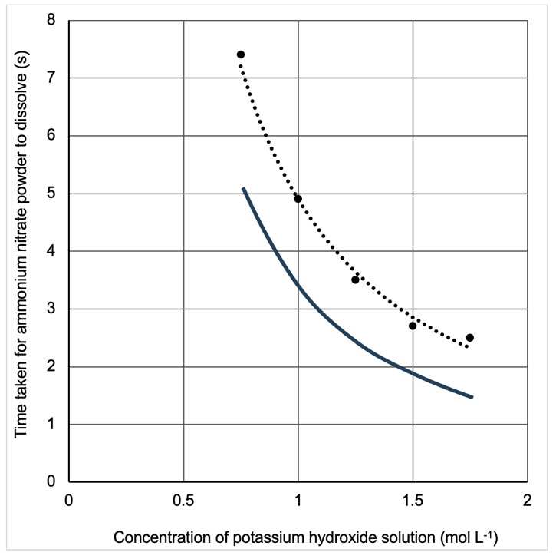
Curve sketched in the same shape, but below, the original data. | 1
Total | 1

(d) Explain the shape of your sketched curve, in terms of the collision theory. (3 marks)

Description | Marks
An increase in temperature increases the average kinetic energy of the particles. | 1
This will increase the frequency and proportion of successful collisions. | 1
Therefore the rate of reaction will be increased (and thus a shorter time taken for the powder to dissolve). | 1
Total | 3

Question 24 (8 marks)

(a) Explain, in terms of structure and bonding, why iron is malleable yet iron(III) oxide is brittle. (6 marks)

Description | Marks
Iron exhibits metallic bonding.  or  Iron exists as a sea of delocalised electrons surrounding positive metal cations. | 1
This bonding is non-directional in nature. | 1
Therefore when a force is applied the iron can change shape without disrupting the bonding. | 1
Iron(III) oxide exhibits ionic bonding.  or  Iron(III) oxide is composed of cations and anions. | 1
The ions are arranged in a rigid 3D lattice. | 1
Therefore when a force is applied the like charges align and repel, causing the substance to shatter. | 1
Total | 6

(b) Calculate the percentage by mass of iron in iron(III) oxide. (2 marks)

Description | Marks
% Fe in Fe₂O₃ = (2 x 55.85) / (2 x 55.85 + 3 x 16) x 100 | 1
= 69.94 % | 1
Total | 2

Question 25 (9 marks)

(a) Name one (1) other heavy metal. (1 mark)

Description | Marks
Mercury / arsenic / chromium / thallium / lead. | 1
Total | 1

(b) Define a saturated solution. (2 marks)

Description | Marks
A solution in which the maximum amount of solute has dissolved, | 1
for a given temperature. | 1
Total | 2

(c) Write a balanced ionic equation for the precipitation reaction that would occur. (2 marks)

Description | Marks
3 Cd²⁺(aq) + 2 PO₄³⁻(aq) → Cd₃(PO₄)₂(s)
Correct species | 1
Correct balancing | 1
Total | 2
Note: State symbols are not required.

(d) Calculate the minimum volume of sodium phosphate solution required to remove all the cadmium ions from the saturated solution. (4 marks)

Description | Marks
m(CdCl₂) = 119.6 x (245 / 100)  = 293.02 g | 1
n(CdCl₂) = 293.02 / 183.3  = 1.5986 mol  = n(Cd²⁺) | 1
n(PO₄³⁻) = (2 / 3) x 1.5986  = 1.06572 mol | 1
V(Na₃PO₄) = 1.06572 / 1.62  = 0.658 L | 1
Total | 4
Note: Award follow through marks in the case of incorrect balancing in part (c).

Question 26 (6 marks)

(a) Write a balanced chemical equation for the reaction that would occur. Use structural formulae for all organic compounds. (2 marks)

Description | Marks
or
Correct reactants | 1
Correct products | 1
Total | 2
Note: Catalyst above arrow not required. Marks may be awarded for substitution of multiple bromine atoms, as long as correct stoichiometry is shown, for example;
CH₃CH₂CH₂CH₃ + 2 Br₂ → CH₃CH₂CHBrCH₂Br + 2 HBr

(b) Write a balanced chemical equation for the reaction that would occur. Use structural formulae for all organic compounds. (2 marks)

Description | Marks
Correct reactants | 1
Correct products | 1
Total | 2
Note: Catalyst above arrow not required. Propan-1-ol may also be accepted as the product, if Markovnikov’s rule is not being assessed.

(c) What is the function of the UV light in part (a) and the sulfuric acid in part (b)? (1 mark)

Description | Marks
Catalyst | 1
Total | 1

(d) Which of the reactions described in part (a) and (b), would be classified as a substitution reaction? (circle your choice) (1 mark)

Description | Marks
(a) | 1
Total | 1

Question 27 (7 marks)

(a) Explain, in terms of intermolecular forces, why the boiling point of nitrogen is much lower than that of water. (3 marks)

Description | Marks
N₂ is non-polar and only exhibits dispersion forces. | 1
H₂O is polar and exhibits hydrogen bonding, as well as (dipole-dipole and) dispersion forces. | 1
The sum of intermolecular forces in H₂O is greater than N₂, therefore a greater amount of energy is required to disrupt them. | 1
Total | 3

(b) Explain, in terms of the kinetic theory, why the pressure inside the container would increase. (2 marks)

Description | Marks
This results in the same number of particles existing in a smaller space.  or  This increases the number of molecules per unit area. | 1
Therefore the frequency of gas particle collisions with the walls of the container would increase (thus increasing pressure). | 1
Total | 2

(c) Describe how this observation illustrates the difference between a real gas and an ideal gas. (2 marks)

Description | Marks
There are no intermolecular forces acting between the particles of an ideal gas. | 1
Intermolecular forces are required to form the liquid state, therefore real gases must exhibit intermolecular forces. | 1
Total | 2

Question 28 (6 marks)

(a) Why are CNTs classified as nanomaterials? (1 mark)

Description | Marks
The diameter / wall thickness of the tube is in the range 1-100 nm. | 1
Total | 1

(b) Describe the economic benefit associated with using catalysts in industry. (2 marks)

Description | Marks
Catalysts increase the rate of a reaction. | 1
This produces more product in a shorter amount of time (which is economically beneficial in terms of generating profit). | 1
Total | 2

(c) Explain, in terms of collision theory, how a catalyst alters the rate of reaction. (2 marks)

Description | Marks
Catalysts provide an alternate reaction pathway with a lower activation energy. | 1
Therefore a higher proportion of particles have sufficient energy to react / to overcome the activation energy. | 1
Total | 2

(d) Identify one (1) way in which an enzyme differs from a metal nanoparticle catalyst. (1 mark)

Description | Marks
Any of the following;  - Enzymes are organic catalysts / of biological origin  - Enzymes are pH sensitive  - Enzymes are temperature sensitive  - Enzymes are proteins  - Enzymes function due to their specific shape | 1
Total | 1

Section Three: Extended answer 40% (72 marks)

Question 29 (19 marks)

(a) Describe how the strontium ions produce an emission spectrum, and why the spectrum emitted is observed as red light. (4 marks)

Description | Marks
Electrons become excited to higher energy levels.  or  Electrons absorb energy and jump up to higher energy levels. | 1
The electrons then return to their ground state.  or  The electrons then fall back down to their original levels. | 1
The difference in energy between the excited state and ground state is emitted as electromagnetic radiation.  or  The photons / energy released by the electrons creates an emission spectrum. | 1
Any one of the following;  The red colour observed is due to;  - the wavelength / frequency of the energy emitted.  - several bands / the predominant bands within the emission spectrum corresponding with the wavelengths of red light.  - the unique arrangement of electrons in strontium.  - the specific energy levels of the electron shells in strontium. | 1
Total | 4

(b) Suggest one (1) ethical consideration that the manufacturers of colour flame candles should consider. (1 mark)

Description | Marks
Any of the following;  - Safety of the candles / ingredients for consumers  - Toxicity of the chemicals used to produce the different colours  - Safety of all chemicals used to manufacture the candle  - Safety of the candles / fumes produced when burning  - Responsible sourcing of materials  - Responsible disposal of any waste materials produced | 1
Total | 1

(c) Calculate the maximum concentration of SrCl₂(aq) solution produced. (You may assume no change in volume when the strontium carbonate is dissolved in the acid). (4 marks)

Description | Marks
m(SrSO₄) = 355 x 10³ g | 1
n(SrSO₄) = 355000 / 183.68  = 1932.71 mol | 1
n(SrCl₂) = 1932.71 mol | 1
c(SrCl₂) = 1932.71 / 925  = 2.09 mol L⁻¹ | 1
Total | 4

(d) Identify a method that could be used to obtain solid strontium chloride from a strontium chloride solution. (1 mark)

Description | Marks
Evaporation / Distillation | 1
Total | 1

(e) Explain, in terms of structure and bonding, why strontium chloride can conduct electricity when molten. Use a relevant chemical equation to support your answer. (3 marks)

Description | Marks
When molten, the ions in SrCl₂ dissociate. | 1
SrCl₂(s) → Sr²⁺(l) + 2 Cl⁻(l) | 1
This produces mobile charge in the form of freely moving ions (thus allowing the liquid to conduct electricity). | 1
Total | 3
Note: State symbols are not required in equation.

(f) State the name given to the group 2 elements. (1 mark)

Description | Marks
Alkaline-earth metals | 1
Total | 1

(g) Identify, in terms of atomic structure, the characteristic common to the group 2 elements. (1 mark)

Description | Marks
Two valence electrons | 1
Total | 1

(h) Explain, by referring to atomic radius, why strontium is more dense than rubidium. (2 marks)

Description | Marks
Strontium has a smaller atomic radius (and a higher atomic mass). / Rubidium has a larger atomic radius (and a lower atomic mass). | 1
Since strontium occupies a lesser volume, it is more dense. / Since rubidium occupies a greater volume, it is less dense.  or  Since the electron shells in strontium are pulled closer to the nucleus, it is more dense. / Since the electron shells in rubidium are further from the nucleus, it is less dense. | 1
Total | 2

(i) Explain, by referring to first ionisation energy, why strontium is less reactive than rubidium. (2 marks)

Description | Marks
Strontium has a higher first ionisation energy / Rubidium has a lower first ionisation energy. | 1
Therefore valence electrons of strontium are more strongly held, thus it is less reactive. / Therefore valence electrons of rubidium are more weakly held, thus it is more reactive.  or  Therefore it is harder to remove the valence electrons from strontium, so it is less reactive. / Therefore it is easier to remove the valence electrons from rubidium, so it is more reactive. | 1
Total | 2

Question 30 (18 marks)

(a) What is a fossil fuel? (2 marks)

Description | Marks
A non-renewable energy source, | 1
formed over millions of years from organic material. | 1
Total | 2

(b) Identify two (2) reasons that it is not desirable for fuels to produce high levels of carbon emissions. (2 marks)

Description | Marks
Any two (2) of the following;  - Global warming / increased global surface temperature  - Ocean acidification  - Glaciers melting  - Increased drought  - Climate change / extreme weather events | 2
Total | 2

(c) Identify two (2) reasons that a country may decide to continue to use coal, despite its associated pollution. (2 marks)

Description | Marks
Any two (2) of the following;  - Use of existing infrastructure  - Lower costs  - Job losses  - Economic concerns  - No affordable alternatives  - Political decision making | 2
Total | 2

(d) Calculate the value of the enthalpy change, in kJ mol⁻¹, associated with this reaction. (4 marks)

Description | Marks
m(C₁₃₇H₉₆O₉NS) = 1 kg  = 1000 g | 1
n(C₁₃₇H₉₆O₉NS) = 1000 / 1932.208  = 0.51754 mol | 1
Enthalpy of combustion = 30.4 / 0.51754  = 58.74 kJ mol⁻¹ | 1
ΔH stated as a negative (-) value / ΔH_{c} used to denote enthalpy of combustion / Written mention of reaction being ‘exothermic’ or heat being ‘released’ or ‘produced’. | 1
Total | 4

(e) Calculate the volume of CO₂(g), at STP, that was produced per person in Australia, due to coal combustion in the year 2020. State your answer to the appropriate number of significant figures. (6 marks)

Description | Marks
m(C₁₃₇H₉₆O₉NS per person) = 95985380 / 25.66 x 10⁶  = 3.7407 t | 1
m(C₁₃₇H₉₆O₉NS) = 3.7407 x 10⁶ g | 1
n(C₁₃₇H₉₆O₉NS) = (3.7407 x 10⁶) / 1932.208  = 1935.952 mol | 1
n(CO₂) = 137 x 1935.952  = 265225 mol | 1
V(CO₂) = 22.71 x 265225  = 6023269 L | 1
= 6.023 x 10⁶ L or 6.023 ML (4 SF) | 1
Total | 6

(f) Write a series of two (2) balanced chemical equations illustrating how the release of sulfur dioxide gas into the atmosphere can lower the pH of rain. (2 marks)

Description | Marks
SO₂(g) + H₂O(l) ⇌ H₂SO₃(aq) | 1
H₂SO₃(aq) ⇌ H⁺(aq) + HSO₃⁻(aq) | 1
Total | 2
Note: State symbols are not required. Double arrows are not required.

Question 31 (16 marks)

(a) Identify three (3) variables the student should control, in order to ensure a valid comparison. (3 marks)

Description | Marks
Any three (3) of the following;  - Mass of ZnCO₃(s)  - Concentration of acid  - Volume of acid  - Temperature of acid  - Size of test tube | 3
Total | 3

(b) Identify two (2) ways in which the observations for the powdered solid would have differed from the solid chips. (2 marks)

Description | Marks
More rapid effervescence / Colourless gas produced at a quicker rate. | 1
Solid dissolved faster / White solid dissolves in shorter amount of time. | 1
Total | 2

(c) Explain, in terms of collision theory, why the observations were different for test tube A and test tube B. (3 marks)

Description | Marks
The ZnCO₃(s) had a smaller exposed surface area in test tube A. / The ZnCO₃(s) had a larger exposed surface area in test tube B. | 1
Therefore the frequency of collisions was lower in test tube A. / Therefore the frequency of collisions was higher in test tube B. | 1
Thus the reaction rate was slower in test tube A. / Thus the reaction rate was faster in test tube B. | 1
Total | 3

(d) Calculate the concentration of CaCO₃(s), in parts per million, in the resulting limewater suspension. (You may assume no change in volume when carbon dioxide is dissolved in the limewater). (8 marks)

Description | Marks
n(ZnCO₃) = 1.04 / 125.39  = 0.008294 mol | 1
n(CO₂ produced) = 0.008294 mol | 1
n(CO₂ dissolved) = (15 / 100) x 0.008294  = 0.001244 mol | 1
n(CaCO₃) = 0.001244 mol | 1
m(CaCO₃) = 0.001244 x 100.09  = 0.1245 g | 1
= 124.5 mg | 1
m(limewater) = 0.0291 kg | 1
ppm = 124.5 / 0.0291  = 4279 ppm | 1
Total | 8

Question 32 (19 marks)

(a) State the name given to structurally different forms of the same element. (1 mark)

Description | Marks
Allotropes | 1
Total | 1

(b) Explain, in terms of structure and bonding, why this is so. (3 marks)

Description | Marks
Both exhibit covalent network bonding. | 1
They consist of strong covalent bonds which needs to be broken for melting to occur. | 1
Therefore a high amount of heat / energy is required (resulting in a high melting point). | 1
Total | 3

(c) Explain, in terms of structure and bonding, the difference in conductivity. (4 marks)

Description | Marks
In diamond, each carbon atom is bonded to 4 other carbon atoms. | 1
All electrons in diamond are therefore localised, leaving no mobile charge to conduct electricity. | 1
In graphite, each carbon atom is bonded to 3 other carbon atoms. | 1
The fourth valence electron of each carbon atom in graphite is delocalised, allowing it to conduct electricity. | 1
Total | 4

(d) On the axes below, sketch an energy profile diagram for the conversion of diamond to graphite. Label the activation energy and enthalpy change. (5 marks)

Description | Marks
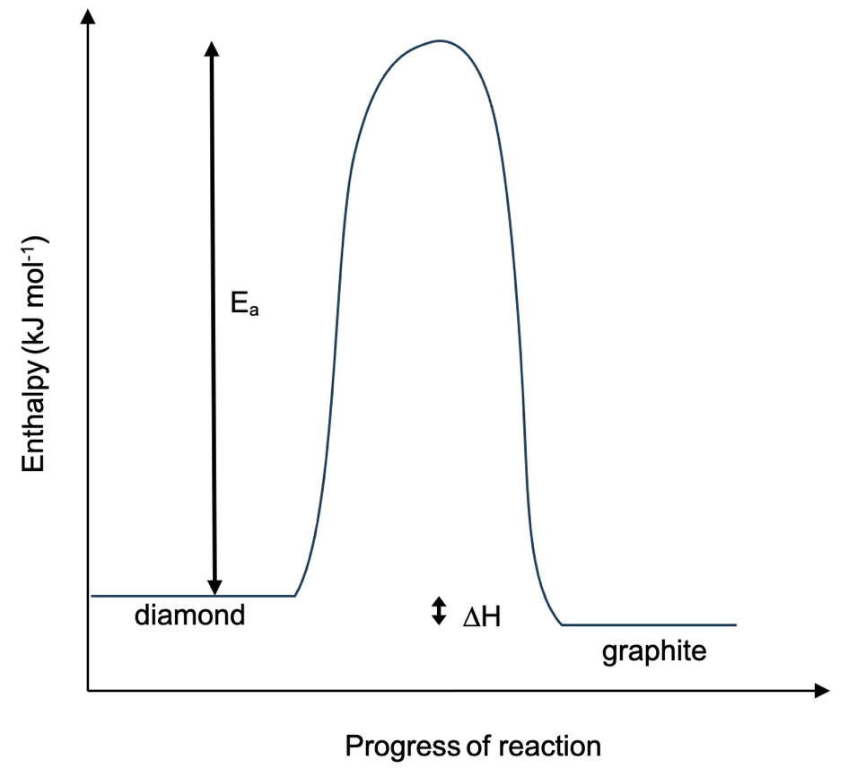

Reactants and products correctly labelled | 1
Activation energy correctly labelled | 1
Enthalpy change correctly labelled | 1
Exothermic profile | 1
Appropriate scale of profile sketch i.e. extremely large activation energy compared to very small enthalpy change | 1
Total | 5

(e) Suggest a likely reason for this. (1 mark)

Description | Marks
The extremely high activation energy. | 1
Total | 1

(f) Calculate the quantity of heat energy absorbed or released during this process. Clearly state in your answer whether heat energy is absorbed or released. (5 marks)

Description | Marks
m(diamond) = 0.77 x 200  = 154 mg | 1
= 0.154 g | 1
n(diamond) = 0.154 / 12.01  = 0.012823 mol | 1
Energy = 1.9 x 0.012823  = 0.0244 kJ or 24.4 J | 1
Energy is released. | 1
Total | 5

